question: Find the solution of f(x) [1,2 ] using bisection method.

f(x)=x^2-2

\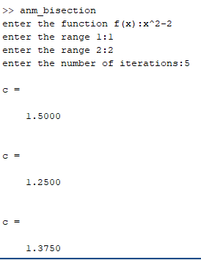

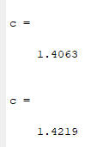

C=1.4219 will be the approximate root